1) Customer Strategy – Understanding our customers.

Customers are at the heart of everything we do here at ChemCorp.

i) What products customers buy the most and what products are bought the least?

By total Revenue customers bought Chemical K the most. The least purchase chemical was Chemical A.

Sheet "Revenue of Product sold most"

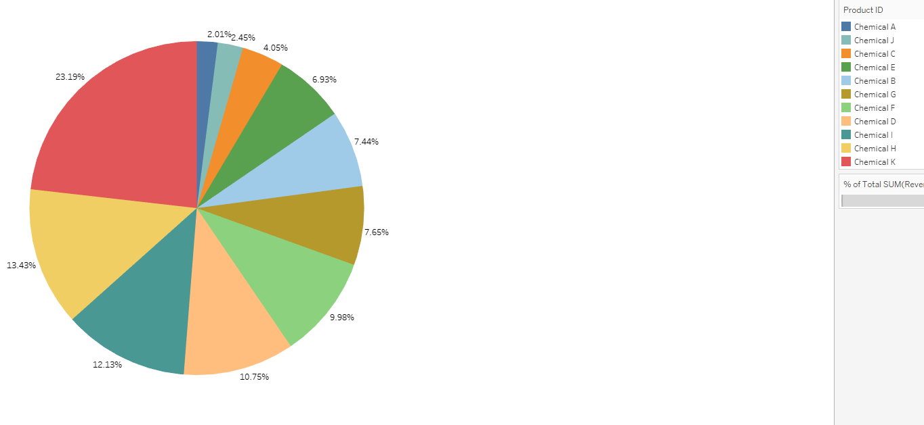

ii) Where most products are being bought

Most of the product is bought in North Central

Sheet "Region that bought most Chemical"

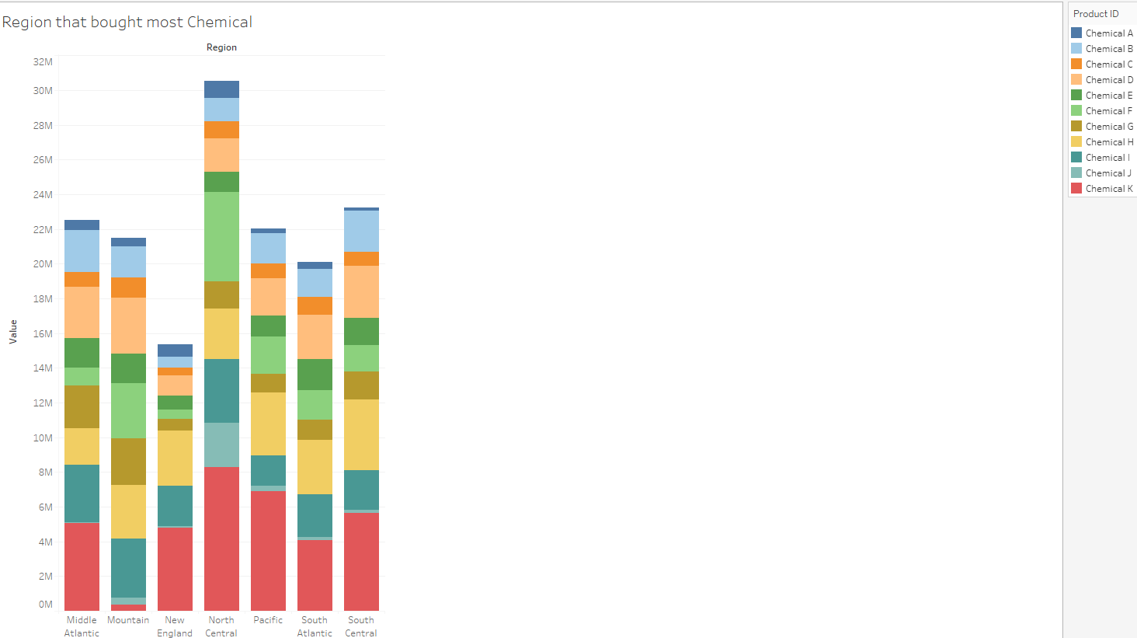

iii) How seasonality plays into the purchase of these products. Are any of our industries or chemicals impacted by seasonal variation?

I have 1-year worth of data and there are 2 chemical that seem to spike. I took median of chemical sold and then plotted against the month. As you can see there are spikes of chemical H. Chemical H seems to spike in May and November. Chemical K seems to have spikes in March and June, then it slowly declines and seems to inline starting in November. The other chemical sees to have some peaks and troughs but they seem more wave and hover around a range.

Sheet "Seasonal Sales"

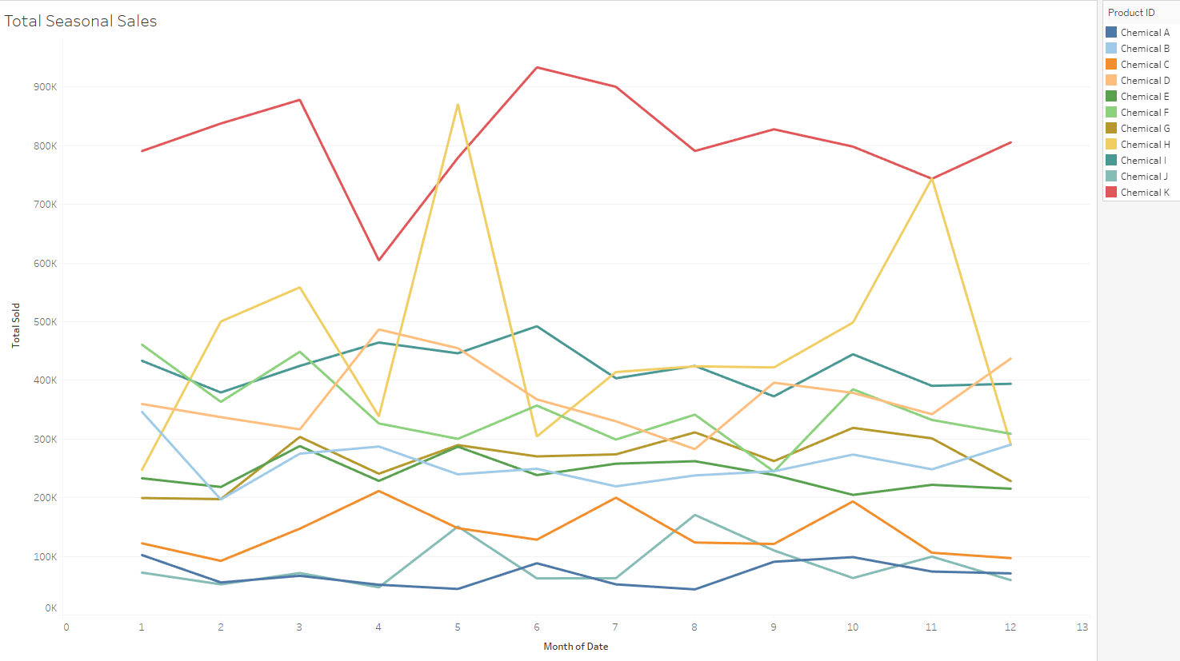

2) Market Opportunities – As we look to the future, what opportunities are we

missing?

i)Which industry provides the most revenue to ChemCorp at this point in time?

Looking at the graph Paper and Packing seems to have the vast market share of the revenue

Sheet “Revenue by Industry”

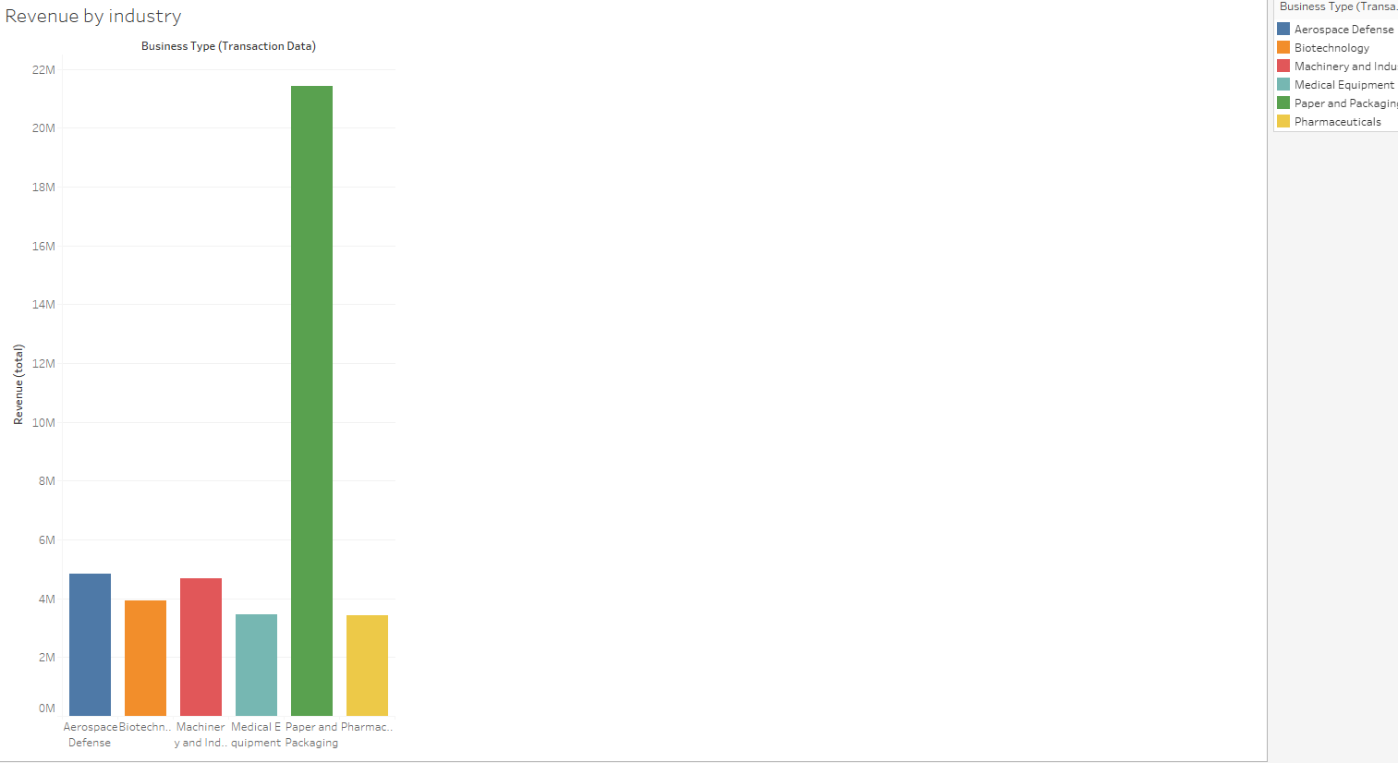

ii)What industries have the highest profit margins and how is this reflected in the number of business customers per segment?

The highest profit margin is Biotechnology

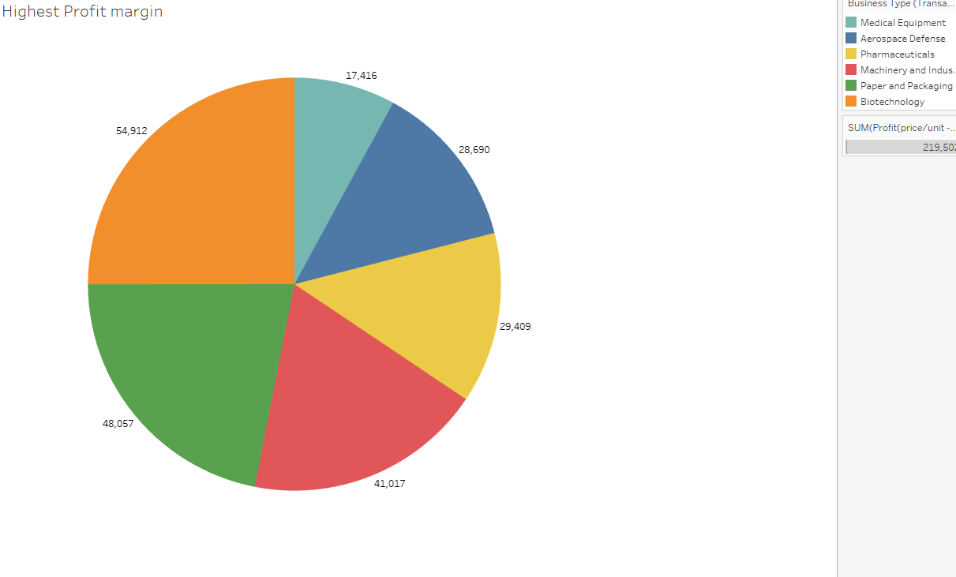 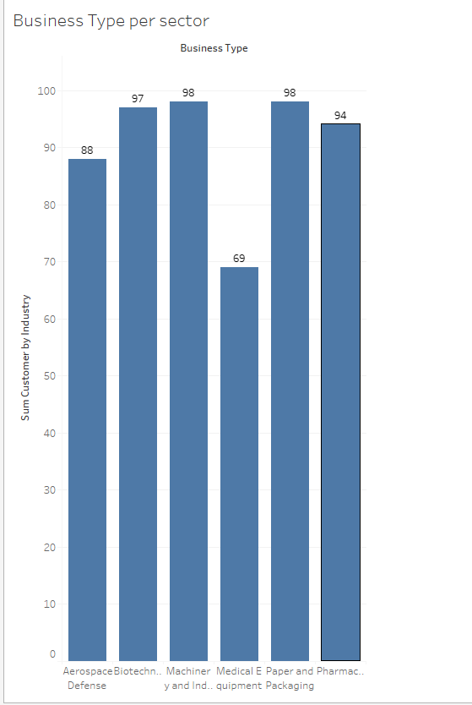

iii) What products provide the highest profitability?

From the chart below I had to take average price – average cost as all contract sells the chemical at different price. Chemical G of profit price is $28.20.

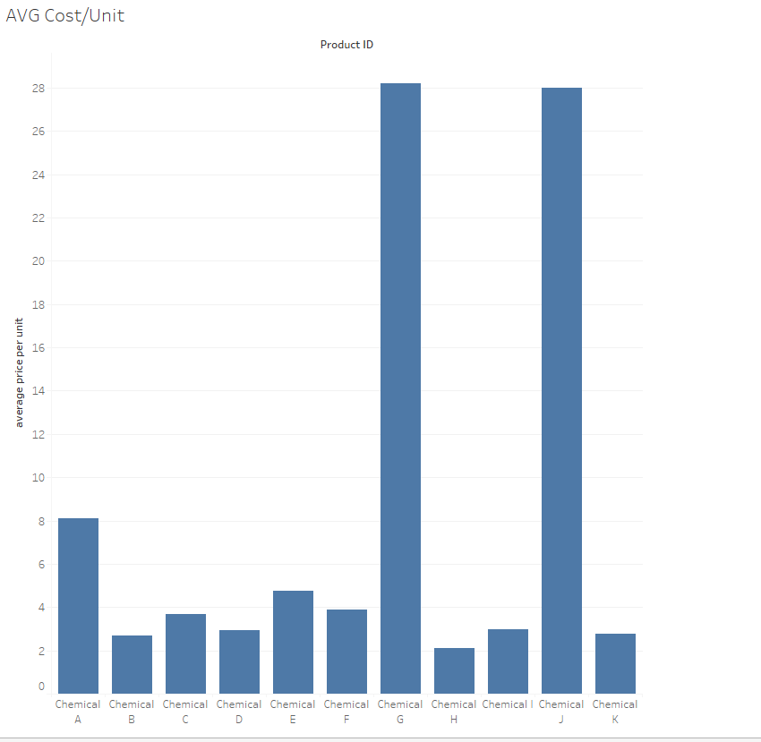

3)Product Divestment – Of the current products that ChemCorp produces, does there exist any chemicals or industries that they should divest themselves of? Copying or posting is an infringement of copyright.

1. Of the six segments ChemCorp’s business has focused on, do any negative or very low-profit margins exist?

None of the 6 business shows a negative profit but the lowest profit is Pharmaceuticals. It has profit of $2,058,922 in 2015

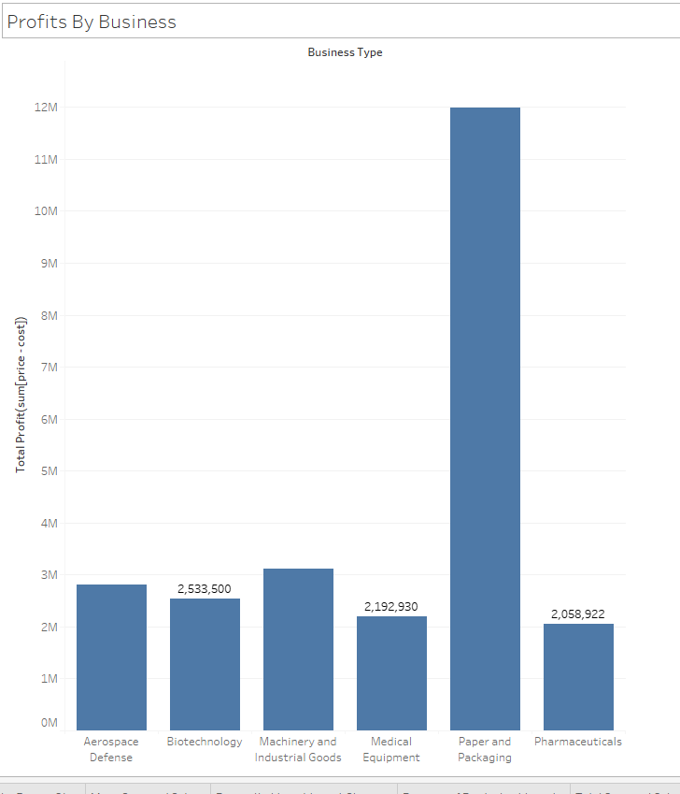

1. Identify insights and/or recommendations to the management team. (You will create a slide deck based on these findings later on in the course.) 1. If the company were to divest in a particular area, where should they focus their resources (i.e. Instead of using resources for Industry X or Chemical Y, they should focus their efforts on Chemical B.)

I would consider either getting rid of Chemical A or J. They are the lowest chemical in terms revenue. The surprising fact is that Chemical J and G are also product with greatest margins. I would consider keeping G and J if I could sell more of those chemicals.

